NAAC A++
Ph.: 07104-237919, 234623, 329249, 329250 Fax: 07104-232376, Website: www.ycce.edu

Department of Computer Technology
Vision Statement of the Department.
To be a preferred hub for nurturing computer engineering aspirants through innovative, ethical, value-based technical education, impactful research, and industry collaboration, to become successful professionals contributing for the betterment of society.
Mission Statement of the Department.
To nurture computer engineering professionals by offering Dynamic learning environment that encourages problem-solving using emerging technology, National Education Policy aligned evidence-based technical education, fostering ,innovation, research, and industry–institute collaboration & Holistic, ethical and sustainable development for lifelong success.

Session 2026-2027

Vision:Dream of where you want. | Mission: Means to achieve Vision

Program Educational Objectives of the program (PEO): (broad statements that describe the professional and career accomplishments)
PEO1 | Preparation | P: Preparation | Pep-CL abbreviation
PEO2 | Core Competence | E: Environment (Learning Environment) | pronounce as Pep-si-lL easy to recall
PEO3 | Breadth | P: Professionalism | pronounce as Pep-si-lL easy to recall
PEO4 | Professionalism | C: Core Competence | pronounce as Pep-si-lL easy to recall
PEO5 | Learning Environment | L: Breadth (Learning in diverse areas) | pronounce as Pep-si-lL easy to recall

Program Outcomes (PO): (statements that describe what a student should be able to do and know by the end of a program)

Keywords of POs:
Engineering knowledge,Problem analysis, Design/development of solutions,Conduct Investigations of Complex Problems, Engineering Tool Usage, The Engineer and The World,Ethics, Individual and Collaborative Team work,Communication, Project Management and Finance, Life-Long Learning

PSO Keywords: Cutting edge technologies, Research

“I am an engineer, and I know how to apply engineering knowledge to investigate, analyse and design solutions to complex problems using tools for entire world following all ethics in a collaborative way with proper management skills throughout my life.” to contribute to the development of cutting-edge technologies and Research.

Integrity: I will adhere to the Laboratory Code of Conduct and ethics in its entirety.

Name and Signature of Student and Date
(Signature and Date in Handwritten)

NAAC A++
Ph.: 07104-237919, 234623, 329249, 329250 Fax: 07104-232376, Website: www.ycce.edu

Department of Computer Technology
Vision Statement of the Department.

To be a preferred hub for nurturing computer engineering aspirants through innovative, ethical, value-based technical education, impactful research, and industry collaboration, to become successful professionals contributing for the betterment of society.
Mission Statement of the Department.
To nurture computer engineering professionals by offering Dynamic learning environment that encourages problem-solving using emerging technology, National Education Policy aligned evidence-based technical education, fostering ,innovation, research, and industry–institute collaboration & Holistic, ethical and sustainable development for lifelong success.

Session | 2024-25 (ODD) | Course Name | Web Technology Lab
Semester | 3 | Course Code | 23CT1301
Roll No | 32 | Name of Student | Arati Lod

Practical Number | 02
Course Outcome | - Understand various internet technologies.  - Design the web pages using HTML and CSS.  - Implement the XML technology to store the data.  - Develop the interactive web pages using JavaScript.
Aim | Create a web form by using form tags in HTML
Problem Definition | To create a web form using HTML form tags for collecting user information such as name, email, gender, and other details.
Theory  (100 words) | A student registration form is a web form used to collect basic information from students. HTML tags are used to create and organize the form fields. The <form> tag defines the form, while <label> provides names for fields. The <input> tag accepts information such as name, email, password, and gender. The <select> and <option> tags create dropdown menus. Submit and Reset buttons are used to submit or clear the entered information. Thus, HTML provides a simple and structured way to collect student details through a web page.

NAAC A++
Ph.: 07104-237919, 234623, 329249, 329250 Fax: 07104-232376, Website: www.ycce.edu

Department of Computer Technology
Vision Statement of the Department.
Procedure and Execution (100 Words) | Step for Implementation:  - Open a text editor such as Notepad, Notepad++, or Visual Studio Code.  - Create a new file and save it with the .html extension (for example,  student_registration.html).  - Type the basic HTML document structure using the  <html>, <head>, <title>, and <body> tags.  - Add a heading for the form using the <h1> tag.  - Create a registration form using the <form> tag.  - Insert labels and input fields for student details such as Name, Date of Birth, Email,  Mobile Number, Password, and Address using the <label>,  <input>, and <textarea> tags.  - Use radio buttons (<input type="radio">) to allow the user to select their gender.  - Use checkboxes (<input type="checkbox">) to let the user select hobbies or skills.  - Add a drop-down list for course selection using the  <select> and <option> tags.  - Include a file upload field using <input type="file"> for uploading a student photograph.  - Add Submit and Reset buttons using <input type="submit"> and <input type="reset">.  - Save the HTML file.  - Open the saved file in any web browser (such as Chrome, Firefox, or Edge).  - Verify that the registration form is displayed correctly  and that all form elements are working as expected.

NAAC A++
Ph.: 07104-237919, 234623, 329249, 329250 Fax: 07104-232376, Website: www.ycce.edu

Department of Computer Technology
Vision Statement of the Department.
Code:

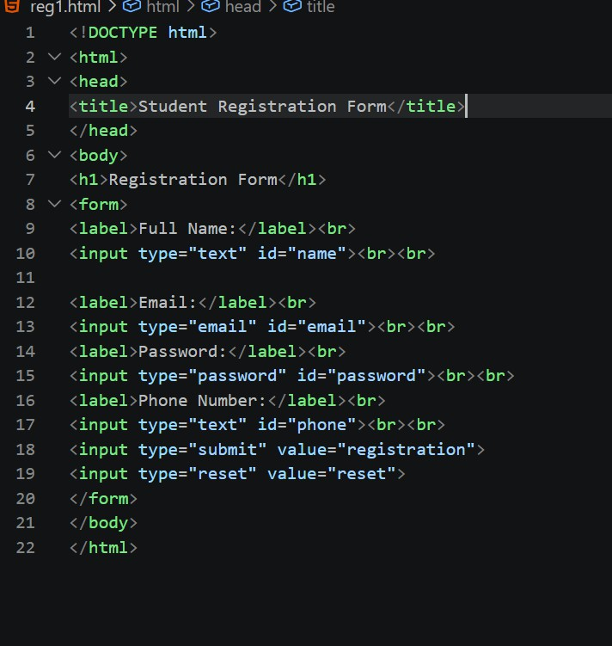

NAAC A++
Ph.: 07104-237919, 234623, 329249, 329250 Fax: 07104-232376, Website: www.ycce.edu

Department of Computer Technology
Vision Statement of the Department.
 | Output: 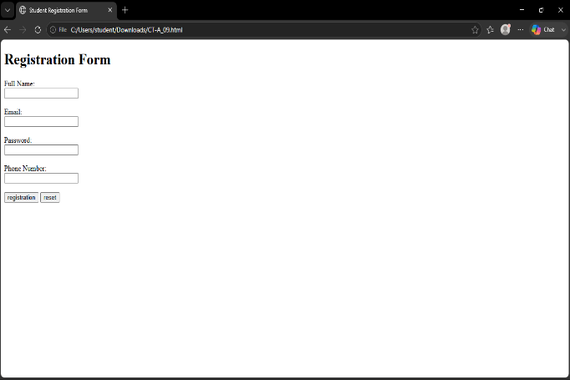
Output Analysis | HTML form tags are used to create interactive forms for collecting user information. Different form controls make the form easy and convenient to use.
Link of student Github profile where lab assignment has been uploaded | https://github.com/aratilod/Web-Technology-Practicals
Conclusion | The web form is successfully created and displayed in the browser. Users can enter information in different fields, select options, and submit the form using the available buttons.
Plag Report (Similarity index < 12%)
Date | 20-07-2026

